HOW TO
A simple seven step guide to adding reviews to your event page on the Adelaide Fringe website
- Log into your AVR account
- Select the drop down box for the event you would like to add a review to
- Select the tab titled ‘Reviews’ and click on ‘Setup Reviews’

- Select the tab ‘+ Add Review’

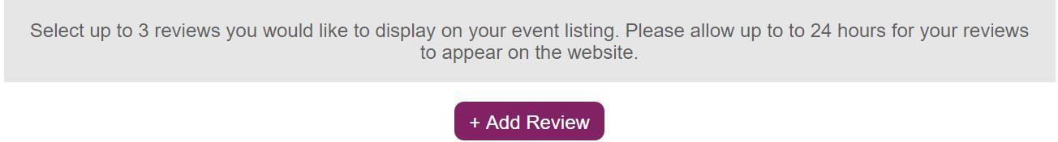

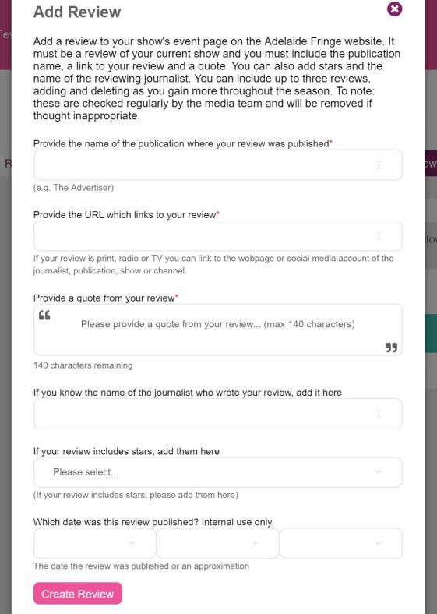
- You will be prompted to fill in the form shown in the image below. Anything with a red star is compulsory – please remember, it must be a review of your current
show and you must include the publication name, a link to your review and a quote

- Once you have filled out the form click on ‘Create Review’

- Your review listing has now been completed – yay! Please allow up to 24 hours to see these on the Adelaide Fringe website.

