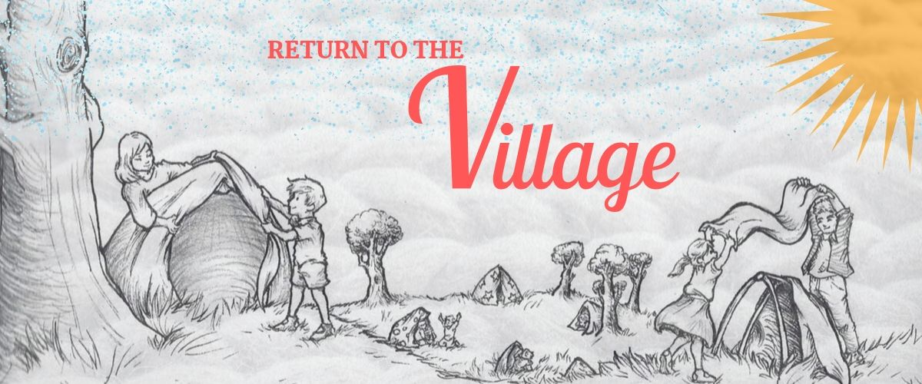
Welcome

Return to the Village is a life-sized game that is immersive and interactive. Designed for children and their families, it’s a theatre piece which doubles as a role-playing event – like a board game come to life.

Role play

The level of role play is completely up to you. Audience members can choose how much or how little they wish to get involved. Activities include things like building a cubby house, sending letters, solving clues, helping collect water and decorating your village.

Families

Bring your tribe! Our huts fit 4-5 people so come along as a family unit or team up with friends. And if you’re flying solo, fear not - we have seating if you prefer to sit back and watch the village unfold.

Relaxed show

Our show is an immersive and gentle experience. While there are plenty of opportunities to get involved and be part of the action, you can also sit back if you prefer. If you have specific access needs, please get in touch so we can work out how best to accommodate you via returnvillage@outlook.com. We are also offering a relaxed performance with the option of tactile tours.

Grandparents

As is the case in many cultures around the world, elders play an important role in sharing knowledge with younger generations. To celebrate the elders in our community, we have seating for grandparents who would like to watch their grandchildren be part of our interactive show.

