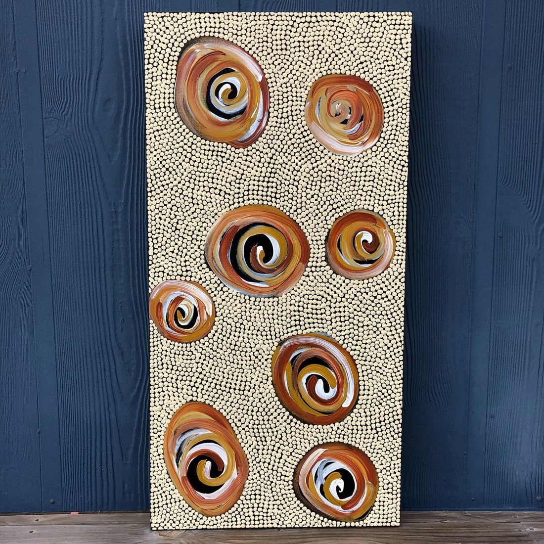
Title: Dry river
Size: 45.7cm x 91.4cm
Price: $550
Using these browns and clay colours I wanted to show what a waterhole/river looks like once dried up. Rivers provide life to country …. they provide habitats for birds and fish and sustenance to Ngarrindjeri people and support the growth of food and medicine plants. We take care of country and in return country provides for us.

